Name:____________________________________ Period:________ SCORE:___________________________

**Secondary 1 Regular - Review Unit 7**

Solve each system by graphing.

1. 2.

 

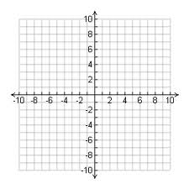 

3. 4.

 

 

5. 6.

 

 

Graph each inequality.

7. 8.

 

 

9. 10.

 

 

11. 12.

 

 

Solve each system by substitution or elimination.

13. 14.

 

15. 16.

 

17. 18.

 

19. 20.

 

**Solve by graphing. Draw a sketch of the graph in the best window, including your axes labeled with the Min and Max. Plot the point(s) of intersection on the sketch, round the co-ordinates to the nearest hundredth if necessary.**

21. 22. 23.

  

24. 25. 26.

  