Name:_______________________________________ Period:____________ SCORE:_________________

**Unit 2 Review – Secondary 1**

**Determine whether the following is a function. Explain why or why not?**

1. 2. 3.

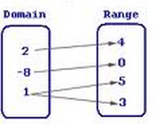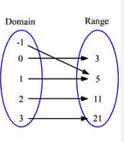

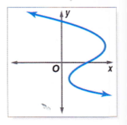

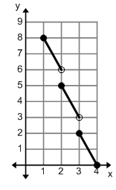

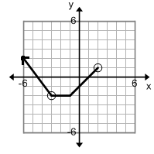4. 5. 6.

**Determine if each set of ordered pairs is a function or not, then state the domain and range.**

7. 8. 

**Determine whether the following is a function. Explain why or why not?**

9. 10. 11. 

|  |  |
| --- | --- |
|  |  |
| -3 | 6 |
| 2 | 9 |
| -4 | 3 |
| 2 | 9 |

|  |  |
| --- | --- |
|  |  |
| -5 | 9 |
| -2 | 1 |
| 4 | 3 |
| 1 | 1 |

**Use , , &  to answer questions 12-21.**

12.  13.  14.  15. 16. 

17.  18.  19.  20.  21. 

**Use  &  to answer questions 22-26.**

22.  23.  24.  25.  26. 

Use the table to answer questions 27-30.

|  |  |
| --- | --- |
|  |  |
| -1 | 8 |
| nterval interval age rate of change for the graph above on the interval __________________screte2 | 0 |
| 3 | 8 |
| -2 | -1 |
| 0 | -2 |
| 4 | 2 |

27.  28.  29.  30. 

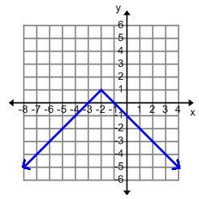

Use the graph to the right to answer questions 31-35.

31.  32.  33. 

34.  35. 

**36.** Describe the features of the graph below using **INTERVAL** notation

Is this a function?__________________ Why?

Domain:________________________________________ Range:_____________________________________________

Continuity: (Circle one) Continuous Non-Continuous Discrete

Increasing:_____________________________________ Decreasing:_______________________________________

Minimum:______________________________________ Maximum: ________________________________________

Positive:________________________________________ Negative:__________________________________________

*x*-intercept(s): _________________________________ *y*-intercept(s): ___________________________________

**37.** Describe the features of the graph below using **INTERVAL** notation

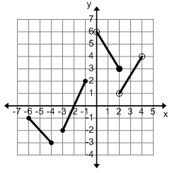

Is this a function?__________________ Why?

Domain:_______________________________________

Range:_____________________________________________

Continuity: Continuous Non-Continuous Discrete

Increasing:_____________________________________

Decreasing:_______________________________________

Minimum:______________________ Maximum: _______________________

Positive:________________________________________ Negative:__________________________________________

*x*-intercept(s): _________________________________ *y*-intercept(s): ___________________________________

**38.** Describe the features of the graph below using **SET** **BUILDER** notation



Is this a function?__________________ Why?

Domain:___________________________________________

Range:_____________________________________________

Continuity: Continuous Non-Continuous Discrete

Increasing:_____________________________________

Decreasing:_______________________________________

Minimum:______________________ Maximum: _______________________

Positive:________________________________________ Negative:__________________________________________

*x*-intercept(s): _________________________________ *y*-intercept(s): ___________________________________

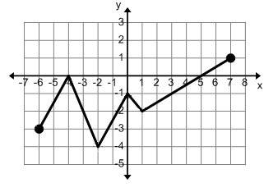

**39.** Describe the features

of the function using

**INTERVAL** **NOTATION.**

Is this a function?__________________

Domain:______________________________________

Range:________________________________________

Continuity: Continuous Non-Continuous Discrete

Increasing:_____________________________________ Decreasing:_______________________________________

Minimum:______________________ Maximum: _______________________

Positive:________________________________________ Negative:__________________________________________

*x*-intercept(s): _________________________________ *y*-intercept(s): ___________________________________

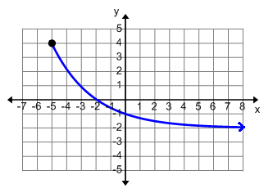

**40.**

Describe the features

of the function using

**INTERVAL** **NOTATION**.

Is this a function?__________________ Why?

Domain:______________________________________

Range:________________________________________

Continuity: Continuous Non-Continuous Discrete

Increasing:_____________________________________ Decreasing:_______________________________________

Minimum:______________________ Maximum: _______________________

Positive:________________________________________ Negative:__________________________________________

*x*-intercept(s): _________________________________ *y*-intercept(s): ___________________________________

**41.** Describe the features of the function using **INTERVAL** **NOTATION**

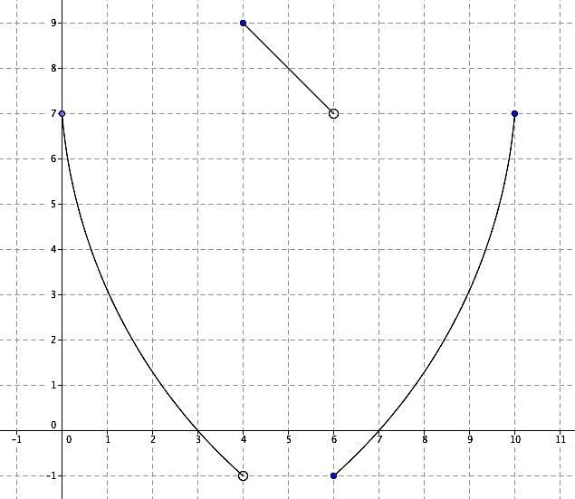

Is this a function?__________________ Why?

Domain:______________________________________

Range:________________________________________

Continuity: Continuous

Non-Continuous

Discrete

Increasing:__________________________________

Decreasing:_______________________________________

Minimum:______________________ Maximum: _______________________

Positive:________________________________________ Negative:__________________________________________

*x*-intercept(s): _________________________________ *y*-intercept(s): ___________________________________

**42.** Describe the features of the function using **INTERVAL** **NOTATION**

Is this a function?__________________ Why?

Domain:______________________________________

Range:________________________________________

Continuity: Continuous

Non-Continuous

Discrete

Increasing:__________________________________

Decreasing:_______________________________________

Minimum:______________________ Maximum: _______________________

Positive:________________________________________ Negative:__________________________________________

*x*-intercept(s): _________________________________ *y*-intercept(s): ___________________________________

**47.** Describe the features of the function using **INTERVAL** **NOTATION**

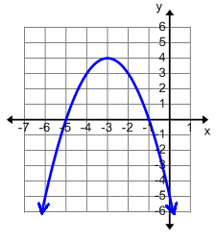

Is this a function?__________________ Why?

Domain:______________________________________

Range:________________________________________

Continuity: Continuous

Non-Continuous

Discrete

Increasing:__________________________________

Decreasing:_______________________________________

Minimum:______________________ Maximum: _______________________

Positive:________________________________________ Negative:__________________________________________

*x*-intercept(s): _________________________________ *y*-intercept(s): ___________________________________

**Create a graph that matches the given descriptions:**

**48.** The function has an intercept at .

The function has no minimum.

The function increases from -5 to 2 and

decreases from 2 to infinity.



**49.** The function has a domain from -9 to 9.

The function has a range from -2 to 7

The function is non-continuous.

The function is positive between -9 to 3.

The function is negative from right after 3 to 9.

**MATCHING**

Match the following descriptions to the graph they BEST represent.

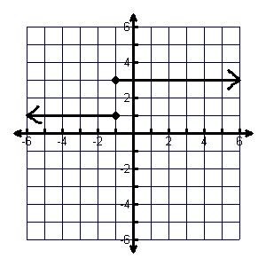

_____________50. The domain is 0 to infinity A.

The range is negative infinity to infinity.

The graph is continuous.

_____________51. The domain is from negative infinity to infinity.

The function has a y intercept at f(0)=3

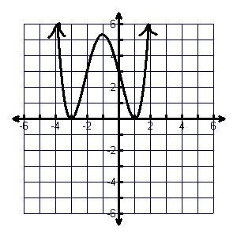 The function never increases and never decreases. B.

The function is non-continuous.

_____________52. The domain is negative infinity to infinity.

The graph is negative from negative infinity to 2.

The graph is always increasing.

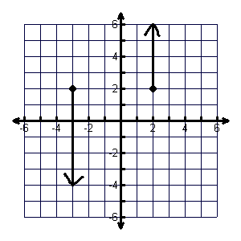 C.

_____________53. The domain is -3 and 2.

The range is negative infinity to infinity.

The function has no min and no max

The function is non-continuous.

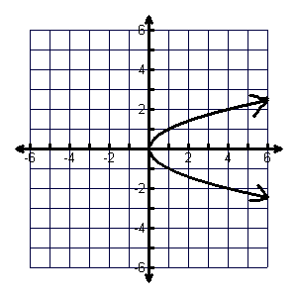 D.

_____________54. The domain is negative infinity to infinity.

The range is 0 to infinity.

The function has two increasing intervals.

The function has minimums at f(-3)=0 and f(1)=0.

E.

