Name: Period:

Score:

____________/__________________________________%

**HW 9-2: Rotations**

Graph the image of the figure using the transformation given.

1. rotation  about the origin

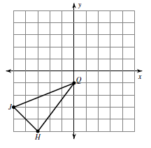

2. rotation  counterclockwise about the origin

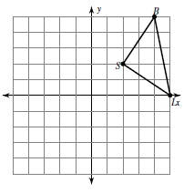

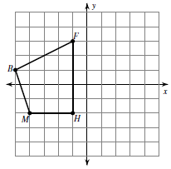3. rotation  clockwise about the origin

4. rotation  about the origin

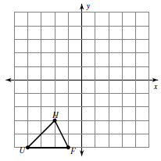

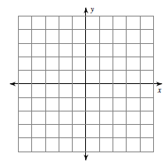5. rotation  clockwise about the origin 

6. rotation  about the origin 

Write a rule to describe each transformation.

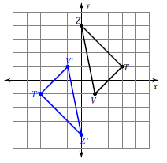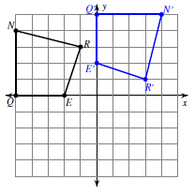

7.

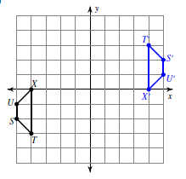

8.

9.

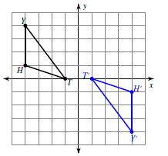

10.