Name Period

|  |  |  |
| --- | --- | --- |
| **Sec1** | **HW 9-1**  **Reflections & Translations** | **Unit 9** |

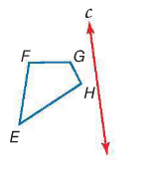**Draw a sketch of the image reflected over the given line.**

1. 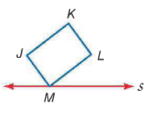

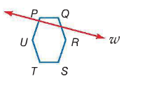

**Reflect the image of  in the given line and state the new vertices.**

1. 
2. 



**New vertices: New vertices:**

**     **

**Graph AND label each figure and its image under the given reflection, then state the new vertices.**

1. ** ** with    in the *x*-axis.
2.  with     in the *y-*axis.

**New vertices: New vertices:**

1. ** ** with    over the line *y* = *x*.
2.  with     over the line *y* = -*x*.

**New vertices: New vertices:**

**Describe the translation using coordinate notation.**

1. 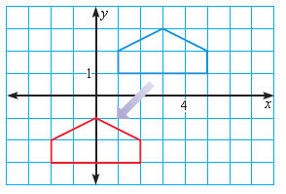
2. 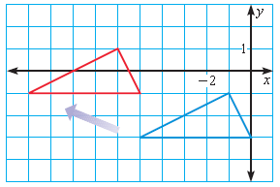

**Consider the translation that is defined by the coordinate notation **

1. What is the image of  ?
2. What is the preimage of  ?
3. What is the image of  ?
4. What is the image of  ?
5. What is the preimage of  ?
6. What is the preimage of  ?

**Use figure  and draw its image after the translation, then state the new vertices.**

1. 

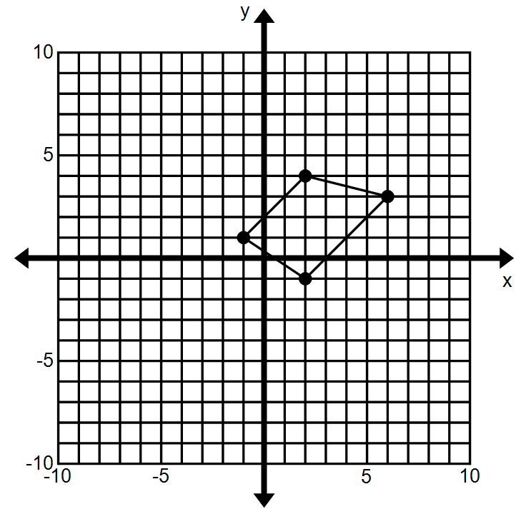

***P***

***S***

***R***

***Q***



***P***

***S***

***R***

***Q***

1. 

**New vertices: New vertices:**