NAME: Period: SCORE:_____/______=______%=______
Sec 1 | HW 8-7  More Calculator Practice  & Causation | Unit 8
The table shows the number of miles Hannah jogged each day for 10 days. Use the linear regression information to answer the following questions.
Day | 1 | 2 | 3 | 4 | 5 | 6 | 7 | 8 | 9 | 10
Miles Jogged | 2 | 2 | 3 | 3.5 | 4 | 4.5 | 2.5 | 3 | 4 | 5

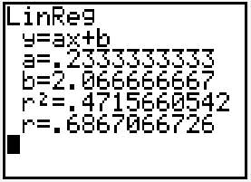
1. Write the equation of the linear regression line for the situation.

2. What does the slope tell us about the story?

3. What does the y – intercept tell us about the story? Does it make sense?
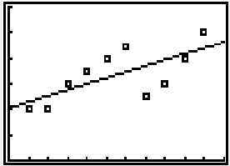

4. Using you regression equation, predict how many miles Hannah would jog on the 15th day.

5. Identify the correlation coefficient for the situation.

6. Interpret the correlation coefficient. (Strength & Direction)

The table below shows Ariana’s hourly earnings for 2001-2007. Let x be the number of years since 2000.
Year | 2001 | 2002 | 2003 | 2004 | 2005 | 2006 | 2007
Hourly earnings (Dollars) | $10 | $10.50 | $11 | $13 | $15 | $15.75 | $16.50

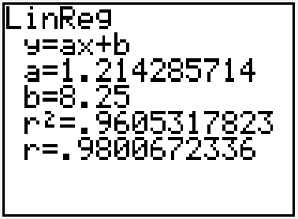
7. Write the equation of the linear regression line for the situation.

8. What does the slope tell us about the story?

9. What does the y – intercept tell us about the story?

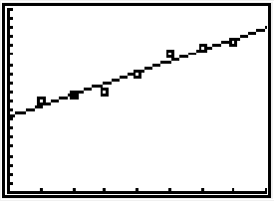
10. Using you regression equation, predict Ariana’s hourly earnings in 2015.

11. Identify the correlation coefficient for the situation.

12. Interpret the correlation coefficient. (Strength & Direction)
A local university is keeping track of the number of art students who use the pottery studio each day.
Day | 1 | 2 | 3 | 4 | 5 | 6 | 7
# of Students | 20 | 19 | 13 | 15 | 18 | 15 | 10

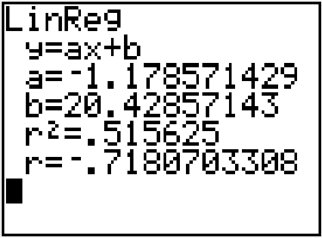
13. Write the equation of the linear regression line for the situation.

14. What does the slope tell us about the story?

15. What does the y – intercept tell us about the story?
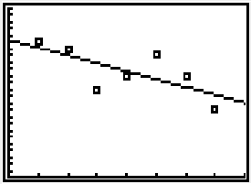

16. Using you regression equation, predict how many students will use the pottery studio on day 13.

17. Identify the correlation coefficient for the situation.

18. Interpret the correlation coefficient. (Strength & Direction)

19. Mr. Jones gave a math test to all the students in his school (grades 1-12). He made the startling discovery that the taller students did better than the shorter ones. His conclusion was that as your height increases, so does your math ability.

Does this imply causation?

Are there any hidden variables that impact your decision regarding causation? If so, describe some of them.

20. Danny is a truck driver for a construction company. The staff at the warehouse loads up his truck with flats of cement bricks while the truck is parked on a scale. They consider the weight of the truck as additional flats of bricks are added to the truck. There is a strong positive relationship between the number of flats loaded onto the truck and the weight of the truck.

Does this imply causation?

Are there any hidden variables that impact your decision regarding causation? If so, describe some of them.

21. There is a strong positive correlation between ice cream sales and shark attacks. As ice cream sales increase, the number of shark attacks increase.

Is it reasonable to conclude that ice cream consumption causes shark attacks? Why or why not.

