NAME: Period: SCORE:_____/______=______%=______
Sec 1 | HW 8-6  Correlation Coefficients | Unit 8

1) What is a correlation coefficient?

2) What would a correlation coefficient of 0 tell you about the graph of the data?

3) What would a correlation coefficient of 1 tell you about the graph of the data?

4) What would a correlation coefficient of -1 tell you about the graph of the data?

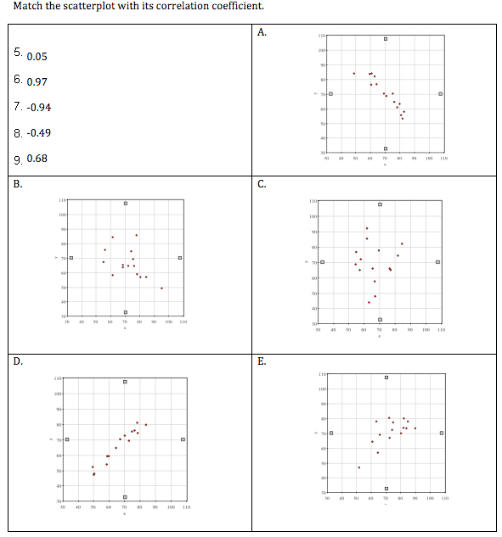

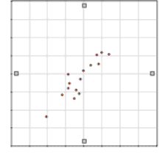
10. The scatter plot to the right compares shoe size and
height in adult males. Based on the graph, do you
think there is a relationship between a man’s
shoe size and his height?

Why or why not?

11. What range do you think the correlation coefficient
for this graph would fall between?

a) -1 to -.5
b) -.5 to 0
c) 0 to .5
d) .5 to 1

Explain why you picked that range.

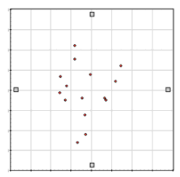
12. The scatter plot to the right compares left-handedness to
birth weight. Based on the graph, do you think being
left-handed is related to a person’s birth weight?

Why or why not?

13. Make your best guess of the correlation coefficient for the
graph. Explain why you chose that number.

Graphing Calculator Needed:

For question 14 - 20 use the following data of the approximate body length of a Panda.
Body Length of Panda
Age (months) | 1 | 2 | 3 | 4 | 5 | 6 | 8 | 9
Body Length (in.) | 8.0 | 11.75 | 15.5 | 16.7 | 20.1 | 22.2 | 26.5 | 29.0

14. Find the equation for the linear regression line.

15. Find the correlation coefficient

16. What does #15 tell you about the correlation?

17. What does the slope tell you about the situation?

18. What does the y-intercept tell you about the situation?

19. Predict the length of an 11-month-old panda using the linear regression equation.

20. Predict how old a panda will be when it is 35 inches long using the linear regression equation.

Graphing Calculator Needed:
For question 21 - 27 use the following data of Movie Tickets Sold in the U.S. by Year.
Movie Tickets Sold in the U.S. by Year
Year | 1998 | 1999 | 2000 | 2001 | 2002 | 2003 | 2004 | 2005 | 2006
Tickets Sold (in million) | 1289 | 1311 | 1340 | 1339 | 1406 | 1421 | 1470 | 1415 | 1472

21. Find the equation for the linear regression line.

22. Find the correlation coefficient

23. What does #15 tell you about the correlation?

24. What does the slope tell you about the situation?

25. What does the y-intercept tell you about the situation?

26. Predict what year the movie sales will reach 1500( in millions) using your linear regression line?

27. What would you expect the movie sales to be in 2015?

