NAME: Period: SCORE:_____/______=______%=______

|  |  |  |
| --- | --- | --- |
| **Sec 1** | **HW 8-5**  **Linear Regression Lines** | **Unit 8** |

**Graphing Calculator Needed for #1-4:**

1. The table below gives the number of annual violin auditions held by a youth symphony each year since 2004. Let  be the number of years since 2004.   
     
     
     
     
     
   a) Enter the data into your graphing calculator and bring up the scatter plot on your calculator screen. Once you have found a good viewing window, **draw a sketch of the graph** in the box below. Be sure to **include labels and to state your viewing window.**  
     
     
     
     
     
     
     
     
     
     
     
     
     
     
     
     
     
     
     
     
     
     
     
     
     
     
     
     
     
   b) Use your calculator to find the equation of the linear regression line. Write the equation below and draw the line into your graph above.  
     
     
   c) What does the slope tell us about the story?  
     
     
     
     
   d) What does the y-intercept tell us about the story?  
     
     
     
     
   e) Using your regression equation, predict how many auditions there would be in the year 2015.

|  |  |  |  |  |  |  |  |
| --- | --- | --- | --- | --- | --- | --- | --- |
| Year | 2004 | 2005 | 2006 | 2007 | 2008 | 2009 | 2010 |
| # of auditions | 22 | 19 | 25 | 37 | 32 | 35 | 42 |

1. The table below ranks the ten tallest buildings in the world.

|  |  |  |  |  |  |  |  |  |  |  |
| --- | --- | --- | --- | --- | --- | --- | --- | --- | --- | --- |
| Rank | 1 | 2 | 3 | 4 | 5 | 6 | 7 | 8 | 9 | 10 |
| # of stories | 101 | 88 | 110 | 88 | 88 | 80 | 69 | 102 | 78 | 70 |

1. Enter the data into your graphing calculator and bring up the scatter plot on your calculator screen. Once you have found a good viewing window, **draw a sketch of the graph** in the box below. Be sure to **include labels and to state your viewing window.**

b) Use your calculator to find the equation of the linear regression line. Write the equation below and draw the line into your graph above.

c) What does the slope tell you about the situation?

d) What does the y-intercept tell you about the situation?

e) Using your regression equation, predict approximately how many stories the 20th ranked building would be.

1. The number of entrants in the Boston Marathon every five years since 1975 is shown below. Let  be the number of years since 1975.  
     
     
     
     
   a) Use your graphing calculator to find the equation of the linear regression line.   
     
     
     
   b) Use the equation to predict how many entrants there were in 2003.  
     
     
     
     
     
     
     
   c) Use the equation to predict what year had approximately 30,000 entrants.

|  |  |  |  |  |  |  |  |  |
| --- | --- | --- | --- | --- | --- | --- | --- | --- |
| Year | 1975 | 1980 | 1985 | 1990 | 1995 | 2000 | 2005 | 2010 |
| # of entrants | 2395 | 5417 | 5594 | 9412 | 9416 | 17,813 | 20,453 | 26,735 |

4) A campground keeps a record of the number of campsites rented the week of July 4th for several years. Let  be the number of years since 2000.

|  |  |  |  |  |  |  |  |  |  |
| --- | --- | --- | --- | --- | --- | --- | --- | --- | --- |
| Year | 2002 | 2003 | 2004 | 2005 | 2006 | 2007 | 2008 | 2009 | 2010 |
| Sites Rented | 34 | 45 | 42 | 53 | 58 | 47 | 57 | 65 | 59 |

a) Find the equation for the regression line.   
  
b) Use the equation to predict the number of campsites that will be rented in 2012.  
  
  
  
  
  
  
  
c) Use the equation to predict the year in which 100 campsites will be rented.

5) Which of the graphs below shows the best trend line for the plotted points? Circle your choice and say **why** it is the best model for the data.

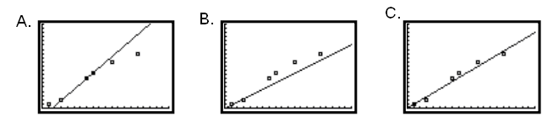

6) In class we learned about linear regression lines. You can also find exponential regression curves. Which of the graphs below shows the best model for the data? Circle your choice and say **why** it is the best model for the data.

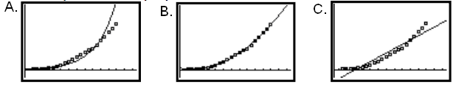

**Review Section:**

Write the explicit equation for each problem.

7)  constant rate of change = 3 8)  common ratio = -3

9)  constant rate of change = -7 10)  common ratio = 2

11)  constant rate of change = - 9 12)  common ratio = 