NAME: Period: SCORE:_____/______=______%=______

|  |  |  |
| --- | --- | --- |
| **Sec 1** | **HW 8-2**  **Histograms** | **Unit 8** |

**\*\*Don’t forget to add LABELS!\*\***

1. The following are test scores from a math class. Create a **frequency chart** and histogram of the test scores. Choose appropriate intervals.

60, 64, 68, 68, 72, 76, 76, 80, 80, 80, 84, 84, 84, 84, 88, 88, 88, 92, 92, 96, 96, 96, 96, 96, 96, 96, 100, 100

|  |  |  |
| --- | --- | --- |
| **Interval** | **Tally** | **Frequency** |
| 60-69 |  |  |
| 70-79 |  |  |
| 80-89 |  |  |
| 90-99 |  |  |
| 100-109 |  |  |

1. U.S. Presidents have entered into office at many different ages. The table below displays the number of presidents inaugurated within different age groups. Use the data to create a histogram.

FREQUENCY TABLE:





1. The frequency table below shows the ages of people attending a high school play. Make a histogram to display the data.

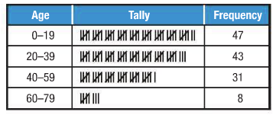



1. The data below shows the free-throw percentages for the players in the Women’s National Basketball Association (WNBA) for 1998. Create a frequency table and a histogram for each conference. Use 31-40 as your first interval for both conferences.

|  |  |
| --- | --- |
| **Women’s National Basketball Association Free-Throw %** | |
| **Eastern Conference** | **Western Conference** |
| 46, 47, 48, 50, 50, 50, 52, 53, 55, 57, 57, 58, 60, 61, 61, 62, 63, 63, 63, 63, 63, 63, 63, 64, 64, 67, 67, 67, 69, 71, 72, 72, 72, 73, 75, 75, 75, 75, 75, 76, 77, 78, 79, 79, 80, 81, 81, 82, 82, 83, 83, 85, 89, 91, 92, 100 | 36, 50, 50, 56, 56, 57, 57, 58, 61, 61, 62, 62, 63, 63, 64, 64, 65, 66, 66, 66, 66, 67, 69, 69, 70, 70, 70, 70, 71, 71, 71, 71, 72, 72, 73, 73, 74, 74, 74, 74, 75, 76, 76, 76, 77, 77, 78, 80, 81, 83, 83, 83, 85, 85, 87, 100, 100, 100 |

|  |  |  |  |  |  |
| --- | --- | --- | --- | --- | --- |
| Eastern Conference | | | Western Conference | | |
| Interval | Tally | Frequency | Interval | Tally | Frequency |
| 31-40 |  |  | 31-40 |  |  |
| 41-50 |  |  | 41-50 |  |  |
|  |  |  |  |  |  |
|  |  |  |  |  |  |
|  |  |  |  |  |  |
|  |  |  |  |  |  |
|  |  |  |  |  |  |

1. The money raised per student in Mr. Brown’s 5th grade class is shown. Create a frequency chart and histogram for the data. Use 1-10 as your first interval.

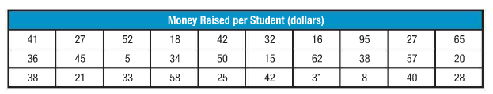



|  |  |  |
| --- | --- | --- |
| **Interval** | **Tally** | **Frequency** |
| 1-10 |  |  |
|  |  |  |
|  |  |  |
|  |  |  |
|  |  |  |
|  |  |  |
|  |  |  |
|  |  |  |
|  |  |  |
|  |  |  |

1. Daily temperatures for the month of December in Houston, TX are shown. Create a frequency table and histogram for the data. Use 40-44 as your beginning interval.

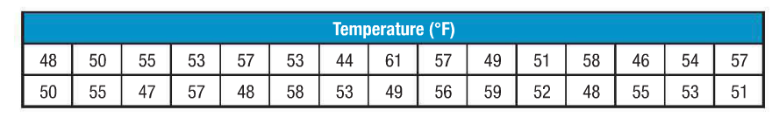



|  |  |  |
| --- | --- | --- |
| **Interval** | **Tally** | **Frequency** |
| 40-44 |  |  |
|  |  |  |
|  |  |  |
|  |  |  |
|  |  |  |
|  |  |  |
|  |  |  |